Annex E – Stage Set Up Templates
- We suggest using a key for any symbols or Motorsport UK notices to keep things symbol
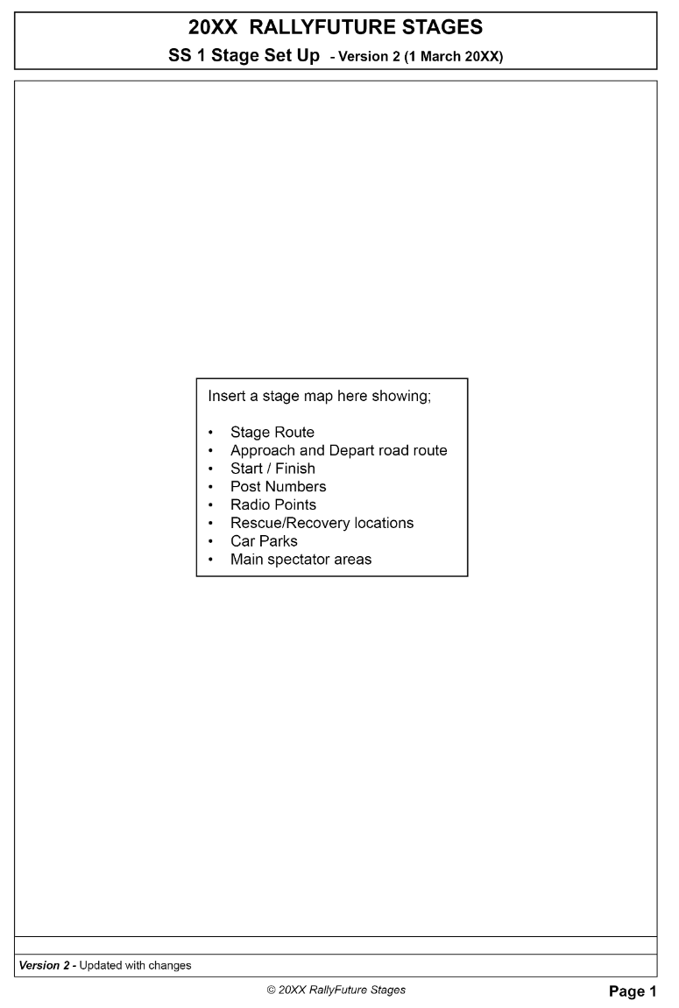
- The below templates are provided as guidance and a starting point; the format is not compulsory, but any alternative formats must be clear, concise and easy to understand and interpret by the Safety Delegate, particularly whilst on the move.

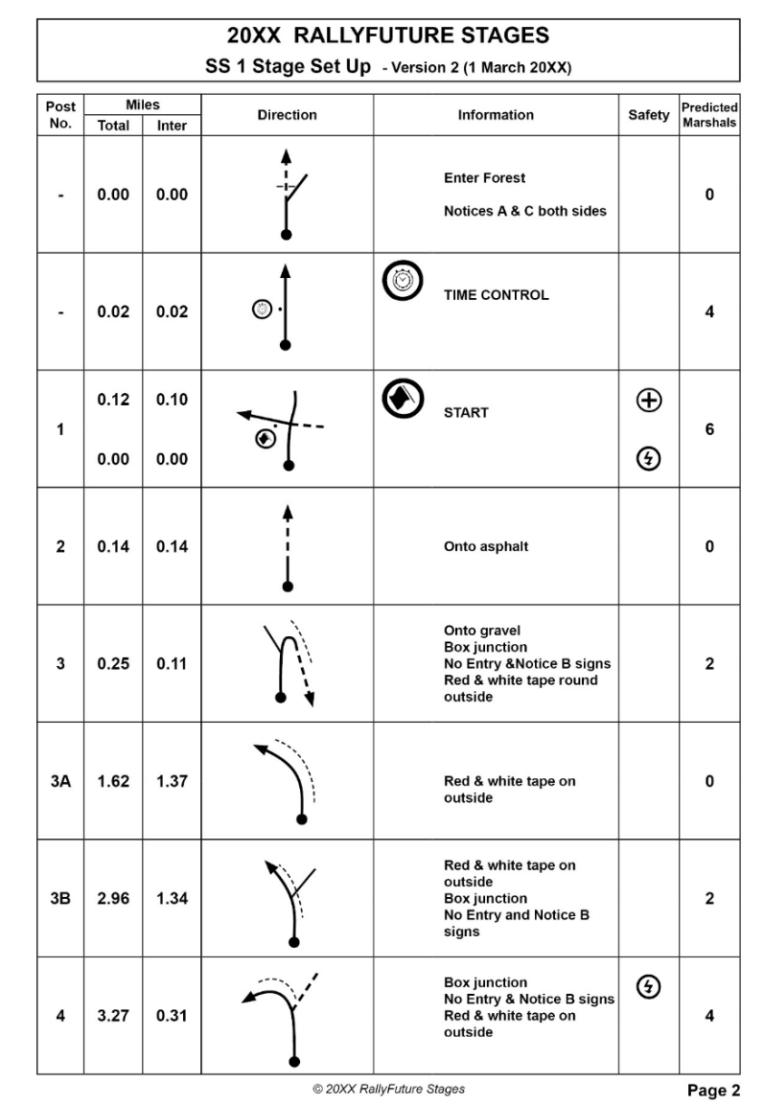

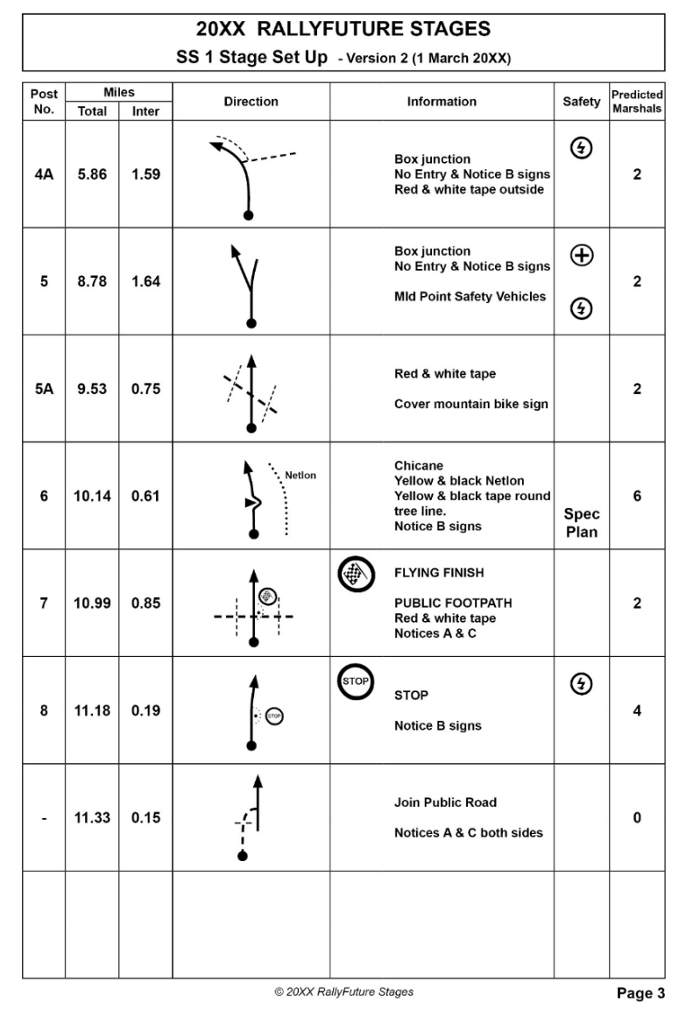

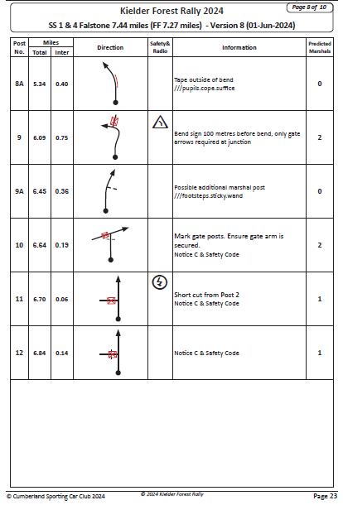

Post No. | Miles |  | Direction | Information | Safety | Predicted Marshals
Post No. | Total | Inter

