

INSERT CLUB NAME

ANTI-BULLYING COMMITMENT

How to use this Template
The purpose of this template is to support clubs to publicise their stance on how they will respond to allegations of bullying.
As a sports club you will see first-hand that a positive motorsport environment supports mental well-being, builds self-confidence, develops relationships and much more. Unfortunately there are a small number of occasions when you may hear about bullying and unfair practices, this template will help you to outline how you will respond to this reports so that you can make sure your activities remain safe, fair and fun for all.
It is recommended that all Registered clubs put in place an Anti-bullying Commitment, in line with your Safeguarding policies and procedures and Race with Respect, to provide clear and well-publicised stance on how you will tackle bullying.
[PLEASE DELETE THIS FIRST PAGE WHEN USING THIS TEMPLATE]

- Introduction
[INSERT CLUB NAME] is committed to providing a safe, fair and fun environment for everyone in motorsport. Bullying of any kind is unacceptable and therefore prohibited by our club.
[INSERT CLUB NAME] Anti-bullying Commitment sets out how we feel about bullying; what we will do to tackle this issue and how we will support people who experience or display bullying behaviour. This commitment aims to contribute to Motorsport UK’s mission, to inspire and enable more people to participate in our sport in a safe, fair, fun, inclusive and progressive environment. To achieve this, we will seek to promote and provide an environment where everyone can feel:
- Safe
- Valued
- Able to enjoy and achieve their potential
- Able to make a positive contribution
[INSERT CLUB NAME] will provide a safe and secure environment by continuously working to prevent acts of bullying, harassment, and other forms of aggression and violence.
  - Definition of bullying
Bullying is behaviour that hurts someone else. It includes name calling, hitting, pushing, spreading rumours, threatening, or undermining someone.
It can happen anywhere, including on line and is usually repeated over a long period of time with the potential to cause both physical and emotional harm.
A bully is someone who deliberately sets out to hurt another person on more than one occasion.
  - Definition of cyber-bullying
Cyber-bullying is the use of technology such as mobile phones, email, chat rooms or social media sites such as Facebook, Snapchat, Instagram or TikTok to harass, threaten, embarrass, intimidate, or target a child/adult. Unlike physical bullying, cyber-bullying can often be difficult to identify and evidence as the bully can remain anonymous when threatening or causing distress to others online.
- Roles and responsibilities
2.1. The role of the Club
[INSERT CLUB NAME] has a responsibility to prevent and tackle bullying. The club will take steps to ensure that all staff and participants act in an inclusive and supportive way to prevent discrimination, harassment, and victimisation within the sport.
[INSERT CLUB NAME] will educate our staff and volunteers to take appropriate steps when they become aware of bullying behaviours.
[INSERT CLUB NAME] will promote the Race with Respect code of conduct in order to encourage and support all members (staff, volunteers, officials and competitors) to speak out about bullying behaviour. The club will follow the Race with Respect procedures to investigate and respond appropriately and proportionately to claims of bullying.
[INSERT CLUB NAME] will review incidences of bullying at Committee meetings to understand if there is anything the club can learn from and do differently in the future to prevent incidences occurring.
2.2. The role of Club Staff and Volunteers
[INSERT CLUB NAME] staff and volunteers will ensure that bullying behaviour is not tolerated or condoned by working in alignment with the Race with Respect code of conduct. , supporting victims of bullying, and reporting incidents they witness or become aware of.
All staff and volunteers working with [INSERT CLUB NAME] will respond appropriately when they become aware of bullying behaviours, they will notify the Club Safeguarding Officer and signpost to support for victims.
2.3. The role of the Club Safeguarding Officer (CSO)
It is the responsibility of the CSO to promote and implement [INSERT CLUB NAME] Anti-bullying Commitment. They will support their colleagues to work in accordance with their Clubs commitment, ensuring that incidences of bullying are identified and responded to appropriately. The CSO will ensure that Race with Respect Codes of Conduct is in place, promoted and signed up to by all participants.
When a CSO receives an allegation of bullying, either directly from the person being bullied, or from a witness, they will speak with all relevant parties to understand what has happened and to collect all the relevant information before making a decision in line with Race with Respect procedures.
The CSO will signpost to any support that is required, if the case involves children, the CSO will work with the parents/ carers and the child to discuss any support required.
  - The Role of Parents/Carers
Parents/carers have a responsibility to support the clubs anti-bullying commitment by actively encouraging their child to be a positive member of the Club.
  - The Role of Competitors
All participants of motorsport activities are encouraged to abide by the Race with Respect code of conduct.
If any competitor is the victim of bullying or cyber-bullying, they should speak with the CSO in the first instance for advice and support.
- Reporting, Sanctions, and Monitoring
3.1. How to Report Bullying
If you are concerned about bullying behaviour in [INSERT CLUB NAME], it is important to report it to [INSERT CLUB SAFEGUARDING OFFICER NAME].
Where possible provide:
- A clear account of the incident, including the names of people involved
- Details of where and when the incident took place
- Details of any witnesses
- Screenshots of any online bullying (if it is safe to do so)
The CSO will respond as outlined in section 2.3 above.
  - Race with Respect
If you do not wish to report incidents of bullying at a club level, reports can also be made online via the Motorsport UK website. Reports are reviewed on a regular basis and actions taken forward by the appropriate sporting lead.
Motorsport UK will follow the Race with Respect procedures and implement sanctions as deemed appropriate and proportionate depending on the level of concern.
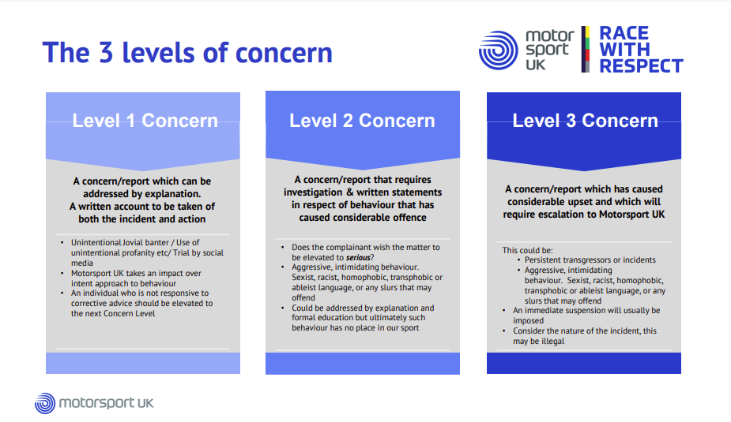
  - Sanctions
Once all evidence has been obtained, the person investigating (whether at a local or national level) will impose a penalty that reflects the bullying behaviour, this may include (this list is not exhaustive):
- Apologising to any effected parties
- Further Education
- Warnings
- Community work
- Championship Penalties
- Championship round suspension / disqualification
- License/Registration suspension
For more information on Race with Respect please see www.motorsportuk.org/racewithrespect/
  - Escalation
If the reporting person is dissatisfied with the way [INSERT CLUB NAME] has dealt with a bullying incident, complaints can be escalated in line with the Complaints policy which can be accessed from Motorsport UK’s website.
- Monitoring, Evaluation and Review
[INSERT CLUB NAME] Club Safeguarding Officer and relevant staff will review this commitment annually and assess its implementation and effectiveness. The commitment will be promoted and implemented throughout the club.
- Support
Different avenues of support can be found on the Motorsport UK website www.motorsportuk.org/the-sport/safeguarding/support/

