Annex C - Safety Plan Template Multi Venue

The RallyFuture Stages
The RallyFuture Stage Rally will be held on 01 January 20XX at Bicester Motion
OX27 8FY under Motorsport UK permit 20221234

The purpose of this safety plan is to:
Insert here, why you feel the safety plan is important and what its purpose is

This plan will be distributed to the following people and agencies
Insert here a list of who will get the document and whether in hard copy or electronically

What other documents do you have/have you produced which should be read in conjunction with the Safety Plan to show the extent of your planning and preparation for the event and its safety elements
Insert here a list of other documents such as your operation plans, your Incident Management Plans, any set up tulips as well as mentioning that you comply with the Motorsport UK Yearbook.

Do you have a Safety Policy – if so, mention it here:
Insert here the policy the event has and takes towards safety

The safety plan should specifically address issues in each of the following areas so make mention of each of these and say what you do about them in general terms linking the sentences to the specific areas that you have covered in your risk assessments.

Safety of the public (including medical/first aid cover);

Safety of the competing crews;

Safety of the volunteers at the event

Event Schedule
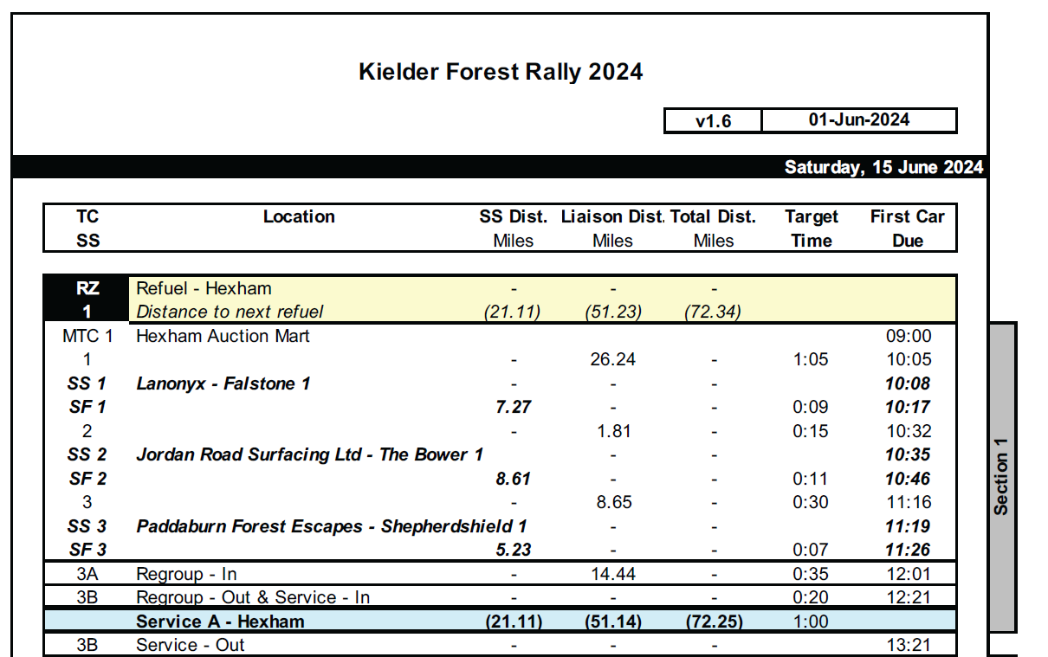

Route Overview and RV points

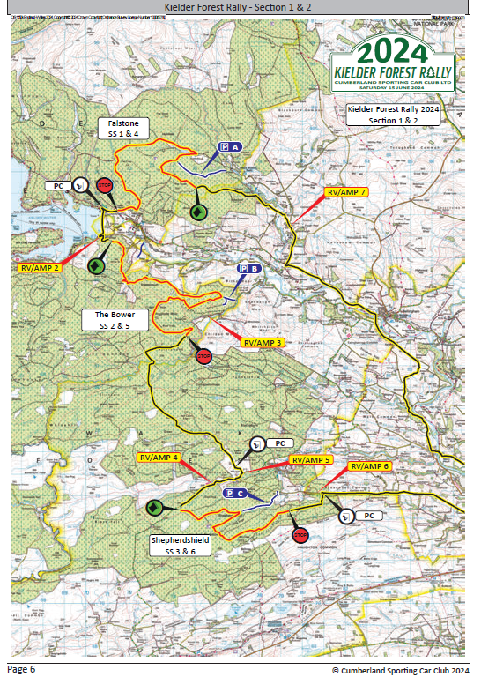

Convoy Diagram
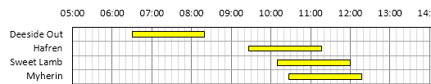

Safety Car Schedule
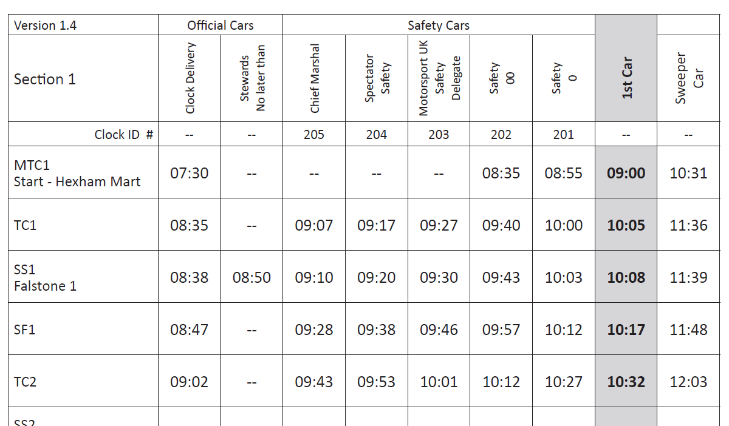

RALLY HQ contact number +44 1234 567 890

Rally Control Emergency Number +44 1234 567 999

Senior Officials on the event
Motorsport UK Safety Delegate Fred SMITH
Motorsport UK Steward and Club Stewards Jane GORDON, Ernest RIGHT, Jo BROWN
Clerk of the Course Tes JAMES
Deputy Clerks of the Course etc
Event Safety Officer
Chief Medical Officer
Spectator Safety Officer
Chief Radio Coordinator
Radio Controller(s)
Stage Commanders for each special stage
Media Officer

Emergency and safety services contact details
Police
Hospitals (including address)
Fire Service
First Aid and casualty transport
Ambulance Service
Rescue Units located at each special stage
Recovery units located at each special stage
Doctor(s) &/or Paramedics located at each special stage
Divers if required
Other??

Risk Management
The plan must describe the risks assessed and how they are to be managed.
There should be specific coverage of the 3 categories of people – Competitors, Officials/marshals and spectators/the public. The example below is a good version of a practical Risk Assessment Template and can be found on the Motorsport UK website resources section for clubs and organisers as well in Annex M. This is not the only way to show the information, the second example is also one that works well.

 | 1. What are the hazards? | 2. Who might be harmed and how? | 3. What are you already doing? | 4. Do you need to do anything else to manage this risk? If so, what? | 5. Action by whom | 6. Action by when | 7. Date complete
1 | Uneven ground and tree trunks | Spectators and marshals | Advising everyone to wear sensible shoes and taping off any excessively bad areas | As the stage is run entirely in daylight no other precautions are in place.  First Aid cover is in place at spectator areas. | Advise marshals of the risks  Notes in programmes and on website | 2 weeks prior to event
2 | Refuel Area | Marshals | 2 metre clear zone  Separate from service area | Fire trained marshals with fire extinguishers in “ready” mode | Service Area Manager | Set-up | Event day

Hazard | Risks Posed | Risk Evaluation | Precautions/controls in place | Further action available | Post action Risk Evaluation
Uneven ground and tree trunks | Personal injury to spectators and marshals | Low to medium | Everyone is advised to wear sensible shoes and any excessively bad areas will be taped off | First Aid available at Spectator Viewing Areas and marshals can radio through to the Stage Commander should there be a problem | Low

(The Incident Management Plan will show what to do if despite your Risk Management Plans there is still an incident or accident).

Spectator Safety
For spectator safety, you could include the following information in your risk assessment table and/or in your stage safety plans/set up diagrams

- Likely numbers of spectators expected and any specific issues that have arisen;
- Plans showing access routes, parking and spectator viewing areas with the relevant text pages on the facing page;
- Motorsport UK Notices and posters plus other signage used on your event;
- Communications to spectators on the event regarding safety e.g. programme, website, safety cars;
- Role of marshals on stage in managing spectators in relation to no-go areas, taped areas and spectator viewing areas;
- Predicted number of marshals per stage and at specific spectator areas;
- Role of stage commander in assisting marshals dealing with unruly spectators i.e. in suspending the stage if spectators do not wish to move when asked;
- The role of the safety cars in managing spectator safety – spec safety, 0, and 00/ 000 if used;
- Any issues specific to your event;
- Map references/GPS locations for stages and RV points

Stage Plans
Also see examples in ANNEX D & E

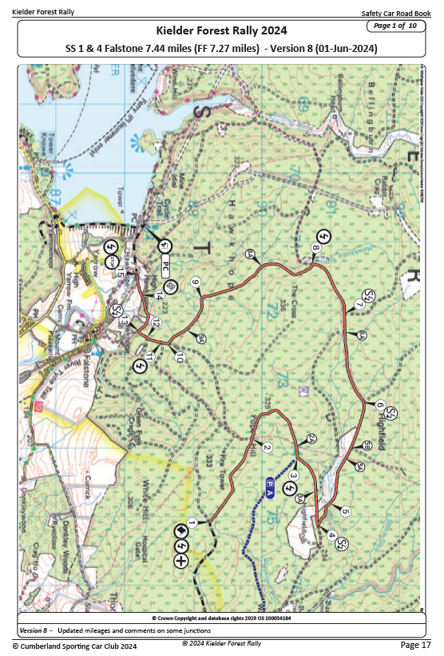

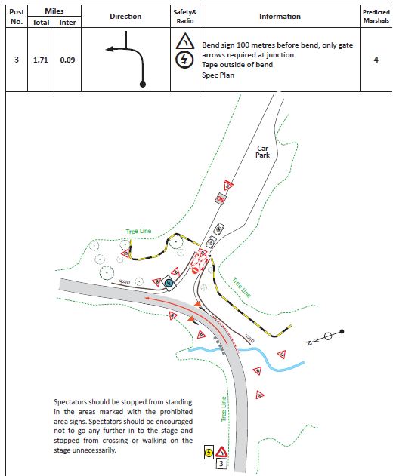
With thanks to the Kielder Forest Team for sharing their examples

