

[
INSERT TEAM NAME]

Safer Recru
itmen
t Procedure

What is the purpose of this
procedure
?

This pr
oc
edure outli
nes
the Safer Recruitment
procedures that
INSERT T
[
EAM NAME]

have in place
to
ensure that those working in our
Team are suitab
le to do so.
The
pr
ocedure details the responsibilities of
the Team
in ensuring Safer Recru
itment
practices

are
embedded

in
[
INSERT TEAM NAME
]
.

What

is Safer Recruitment?

Safer Recruitment is the term used to describe the processes undertaken by an
organisation to prevent those willing to harm or abuse children, young
people and

adults at risk from working within the

Team
.

This includes
several

processes, including the need for Suitability Checks (DBS/PVG) for
those in
R
egulated
A
ctivity. It can also include a formal interview process or asking an
applicant to self
-
declare any unspent convictions when they apply to volunteer or work
within your club environment.

Possible risks for
[
INSERT TEAM NAME]

Safer Recruitment practices are measures designed and implemented to keep everyone
in motorsport safe; it is a vital part of our role in Safeguarding those within the
community. These practices ensure that
[
INSERT TEAM NAME]

meet their duty of care
to ensure that unsuitable people are prevented from working within motorsport.

]
INSERT TEAM NAME
[

have a moral and legal duty to adopt Safer Recruitment
practices. Allowing unsuitable people to work with children, young people and adults
at risk can put the most vulnerable members of your club at risk of harm.

Using
this
template:

This template is intended for use
by Motorsport U
K
Registered T
e
ams
to outline their
Safer Recruitment Procedures.

Please
insert your
Team
’
s name and
Logo where appropriate

Please ensure this box is deleted before the
procedure

is published.

[INSERT TEAM NAME]’s Responsibilities in Safer Recruitment
- Ensuring that all Team staff working in regulated activity have a current Suitability Check (DBS/PVG) in place.
- Reporting anyone who avoids or refuses to complete a Suitability Check to Motorsport UK.
- Preventing anyone on the children’s or adult’s barred list from working within the sport.
- Maintaining oversight of the Motorsport UK Suspensions Register and ensuring any conditions are implemented.
- Reporting any concerns or reports of harm, abuse or neglect to children, young people or adults at risk to Motorsport UK Safeguarding Team or statutory agencies, where necessary.

Regulated Activity
Those working in Regulated Activity must have a Suitability Check (DBS/PVG) in place with Motorsport UK or be a part of the DBS Update Service.
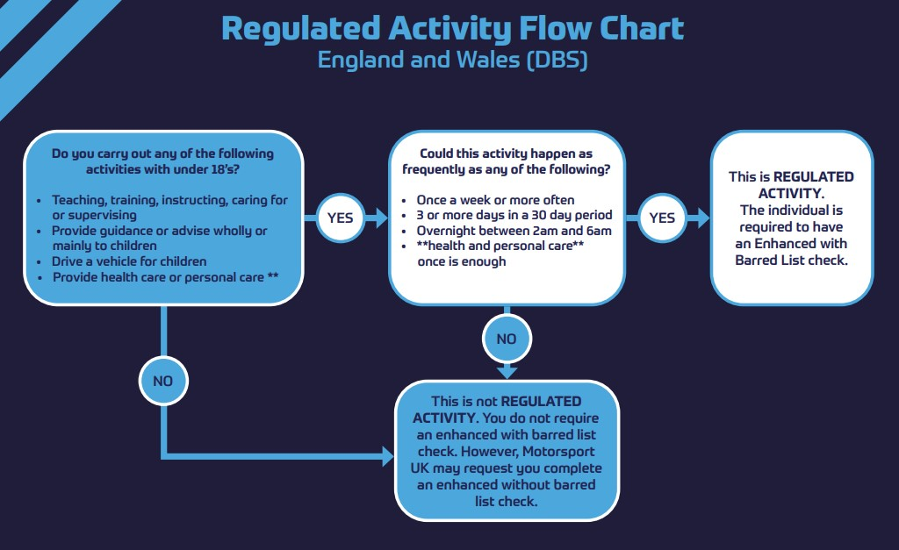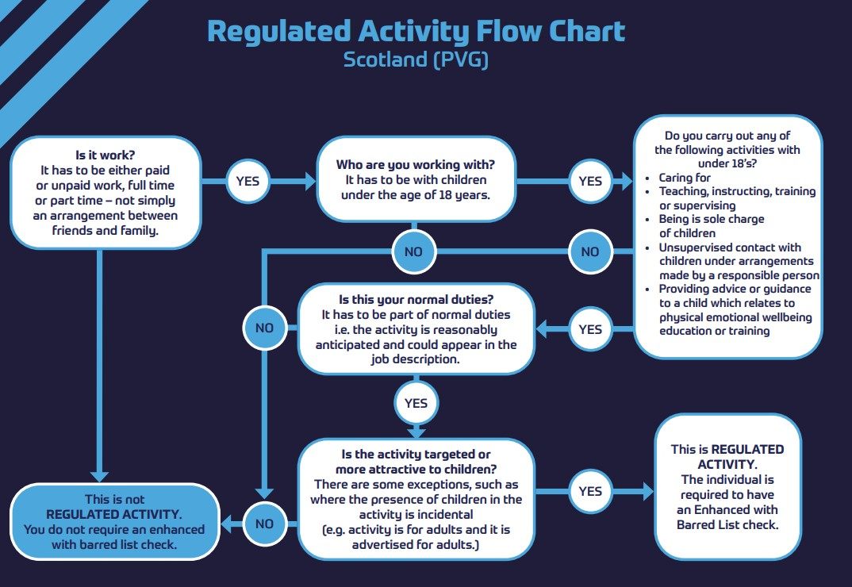
The following Team roles are considered to constitute Regulated Activity:

- Team Manager
- Approved Driver Coaches
- Mechanics working with U18’s
- Instructors of U18’s

Safer Recruitment Key Considerations
- Safer Recruitment applies to both paid and voluntary staff
- Staff and Volunteers should all have clearly defined roles and responsibilities within the Team
- Safer Recruitment allows parents to be reassured that your Team is working to protect their child and prevent unsuitable people from working within the Club
- Applying Safer Recruitment processes will promote a positive reputation of the Team
- Safer Recruitment ensures that the right person with the right skills and experience is working in the correct role
- Gaps in employment history, or any concerns from previous employees should be considered with regards to their suitability to work with children, young people and adults at risk

Self-Declaration Forms
[INSERT TEAM NAME] may ask a person to complete a self-declaration form to disclose any information or previous convictions if they do not meet the threshold for a Suitability Check (DBS/PVG).
These forms will be stored securely, and information will be shared only on a need to know basis.

Completing a Suitability Check
If you meet the thresholds for Regulated Activity within the Team, [INSERT TEAM MANAGER’S NAME] will request that you complete a Suitability Check. This will be submitted through the Motorsport UK Safeguarding Team.
If you are a volunteer with the Team, this check will be free of charge. If you are a paid employee of the Team, you will be invoiced for the check (approximately £60). Checks last for 3 years from the date of issue.
The following information is required by [INSERT TEAM NAME] to submit the application for your check.
- Applicant’s full name
- Applicant’s email address
- Motorsport UK Licence Number (where applicable)
- Where the applicant currently lives

Advertising a Role
Prior to hiring a new staff member, [INSERT TEAM NAME] have a robust hiring process in place to ensure consistency and suitability for each role.
[INSERT TEAM NAME] will use this process as an opportunity to outline our values and ethos and include our commitment to Safeguarding.
If the role falls under regulated activity, the need for a Suitability Check will be highlighted at the start of the process. This is to hopefully discourage any potential candidates who are unsuitable to work with child, young people or adults at risk.

The Hiring Process
[INSERT TEAM NAME] are committed to ensuring that our hiring process is consistent for all roles. This includes:
- Advertisement of the Role – Either internally or externally
- A job description – to outline the role and highlight expectations
- A person specification – to outline the skills, values and experience required for the role
- Interviews
- Suitability Checks (where applicable)
- Induction, training and education – how the Team runs and its ethos and values

Training and Education
Safeguarding children, young people and adults at risk is everybody’s responsibility. [INSERT TEAM NAME] hold the safety of our children and young people in the utmost importance. We will educate our Team staff around our Safeguarding Policy and the values we hold as a Team.
Motorsport UK run a Driving Safer Cultures training session aimed at Teams and we will ensure that our Team Staff have attended this training, where appropriate.

