

INSERT CLUB NAME

Missing & Separated
Persons Procedure
- Introduction

INSERT CLUB NAME have a responsibility for the safety and welfare of the Participants, Officials and Marshals at their Permitted events. INSERT CLUB NAME must also ensure that events are organised and delivered in a safe way with all reasonable risks addressed. This document explains the roles and responsibilities of INSERT CLUB NAME, and other relevant bodies in responding to reports of missing or separated persons.
The purpose of this procedure is to provide a comprehensive approach for all events run by INSERT CLUB NAME in conjunction with Motorsport UK to ensure a proportionate and consistent response to any reports of missing or separated persons (both adults and children). It encompasses proactive measures to prevent incidents and provides a clear response plan to ensure the safe return of those who have gone missing or become separated during an event.
By implementing these detailed steps in the Missing or Separated Persons Procedure, INSERT CLUB NAME aims to ensure a prompt and effective response to incidents, prioritising the safety and well-being of individuals, and facilitating their reunification with their families or guardians.

- Key Definitions

Missing Person(s) - A missing person is one whose whereabouts are unknown to his/her relatives and/or who, based on reliable information, has been reported missing.
Separated Person(s) – A separated person is one who has lost sight of those in attendance with relative / family members / friendship group.
Vulnerable Person(s) - A vulnerable person is an individual who may be at a higher risk of harm or exploitation due to various factors, such as their age, physical or mental health condition, disability, or social circumstances.
Found Person(s) - A found person refers to an individual who was previously reported as missing or separated and has been located or returned to a place of safety.

- Proactive Measures

  - Communication and Awareness
Prior to all INSERT CLUB NAME events:
- The Missing and Separated Person(s) procedure is reviewed by the event lead and shared with all appropriate Officials and Marshals.
- The Missing and Separated Person(s) procedure is disseminated to participants and other attendees through various channels (including websites, social media, event brochures) to educate attendees about the importance of personal safety and to increase awareness of the risks of separation.
- Clear signage is displayed throughout the venue(s) indicating designated meeting points, lost, and found areas, and emergency contact numbers.

  - Identification and Security
While at INSERT CLUB NAME events:

- Officials and Marshals should wear visible identification to support reporting of missing or separated persons.

- Reporting Processes

  - Initial Reports
INSERT CLUB NAME will ensure:
- Officials, marshals and other volunteers are made aware of the procedure.
- Officials, marshals and other volunteers have an understanding of the designated persons at the event who they need pass reports of missing or separated persons onto.

  - Information Gathering
Trained Club Safeguarding Officers or Safety Officers must be available at INSERT CLUB NAME events to collect comprehensive information about the missing or separated person and obtain contact details of the reporting person.
Relevant information to obtain will include the person's full name, age, gender, physical description, clothing description, any unique identifiers (such as tattoos or birthmarks), and any relevant medical conditions or special needs. The reporting person should be requested to provide photographs of the missing person, if available.
The questions below are prompts that can be used by trained Club Safeguarding Officers, Safety Officers or other designated persons to gather appropriate information.

Guardian missing / separated from child | à  à  à  à  à  à  à  à  à | Child missing / separated from Guardian
1. When was the last time you saw your child? | à  à  à  à  à  à  à  à  à | 1. When and where was the last time you saw your parents / guardian?
2. Can you provide a detailed description of your child, including physical appearance, height, weight, hair colour, eye colour, and any distinguishing features like birthmarks or scars? | à  à  à  à  à  à  à  à  à | 2. Can you provide any details about your guardian’s appearance or any identifying information that could be helpful in locating them?
3. What was your child wearing when you last saw them? | à  à  à  à  à  à  à  à  à | 3. Have you tried reaching out to your guardians via phone calls, messages, or other means of communication?
4. Do they have any specific clothing items or accessories that could help with identification? | à  à  à  à  à  à  à  à  à | 4. Do you have any information about your guardian’s plans of where they were going before the separation?
5. Did your child mention any plans or intentions before going missing? | à  à  à  à  à  à  à  à  à | 5. Have you contacted any other trusted adults or family members to seek assistance or inform them about the separation?
6. Is there anyone your child might have gone to meet or any specific locations they wanted to visit? | à  à  à  à  à  à  à  à  à | 6. Are there any known reasons or circumstances that might have led to the separation from your guardian?
7. Do you have any recent photographs of your child that can be shared with law enforcement or used for staff dissemination? | à  à  à  à  à  à  à  à  à | 7. Is there any additional information or context that might be helpful in understanding the situation?
8. Have you tried contacting your child’s mobile phone? | à  à  à  à  à  à  à  à  à | 8. Have you considered any places your guardian may have gone or reached out to mutual friends or acquaintances who might know their whereabouts?
9. Are there any known conflicts, disputes, or issues your child may have been involved in prior to their disappearance? | à  à  à  à  à  à  à  à  à | 9. Do you have any documents or contact information that could assist in locating your guardian, such as their address, workplace, or emergency contacts?
10. Are there any known medical conditions, allergies, or special needs that could be relevant to the search efforts? | à  à  à  à  à  à  à  à  à | 10. Are there any recent conflicts, disputes, or incidents that might have contributed to the separation?
11. is there any additional information or details that you think may be important for us to know? | à  à  à  à  à  à  à  à  à | 11. Is there anything else you would like to share or any questions or concerns you have regarding the separation from your guardian?

  - Immediate Actions
On receipt of a report of a missing or separated person, the person receiving the report must notify the INSERT CLUB NAME Event Lead, Safety Officer or Club Safeguarding Officer immediately.
The designated person must:
- Activate the clubs Missing or Separated Persons Procedure immediately upon receiving a report.

- Initiate communication with local law enforcement agencies to establish coordination and collaboration in the search efforts. (Follow flow chart for timings)

- Ensure clear communication channels are established between the reporting stations, event organisers, security personnel, and local law enforcement agencies.

- Assessing Risk
Risk factors related to a missing or separated person case involves a comprehensive evaluation of various factors, including the circumstances of the disappearance, the individual’s vulnerability, and any other potential dangers they may be exposed to. The risk matrix helps prioritise efforts and allocates resources effectively.

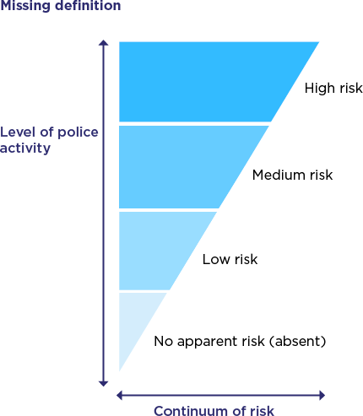

No apparent risk (absent)
There is no apparent risk of harm to either those missing / separated or the public. | Actions to locate the person(s) and/or gather further information should be agreed with the parent and/or guardian and a latest review time set to reassess the risk.
Low risk
The risk of harm to the person(s) or the public is assessed as possible but minimal. | Proportionate investigate should be carried out to ensure that the individual has not come to harm – Investigate and resources should be made aware and alerted.
Medium risk
The risk of harm to the person(s) or the public is assessed as likely but not serious. | This category requires an active and measured response by the event staff and other agencies in order to trace the missing person(s) and support the person reporting.
High risk
The risk of serious harm to the person(s) or the public is assessed as very likely. | This category requires the immediate deployment of police resources – action may be delayed in exceptional circumstances, such as searching areas during hours of darkness. A member of the senior management team must be involved in the examination of initial lines of enquiry.

- Responses
Depending on the level of assessed risk, INSERT CLUB NAME may deem the following actions to be appropriate:
  - Coordinated Search Teams

- The Safety Officer in consultation with the Club Safeguarding Officer (and local law enforcement) should coordinate search teams consisting of venue and event personnel, volunteers, and security professionals.

- Each team must be provided with detailed descriptions and photographs of the missing or separated person and allocated specific areas or zones to search.

  - Systematic Searches

- Systematic searches of designated areas should be conducted based on available information about the missing or separated person's last known location and possible movement patterns.

- The Safety Lead must maintain constant communication with the search teams to ensure clear oversight of actions and timings.

- Search techniques must be appropriate for the venue, including grid searches, dog units where necessary, and crowd monitoring systems if available.

  - Technological Assistance

- If available, technology such as CCTV cameras and crowd monitoring tools should be utilised to aid in locating missing or separated individual(s).

- Collaborate with the event's technical team to optimise the use of available technology for search and rescue efforts. Consider any advanced technologies available at the event venue.

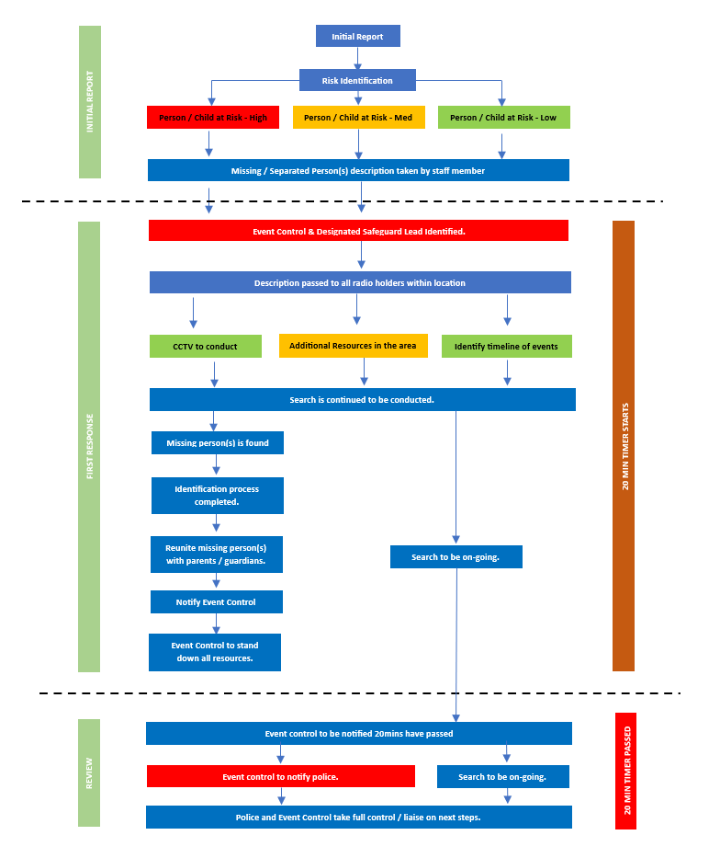
- Missing/Separated Person Flow Chart

- Found or Missing Person Resolution
To ensure the safety and well-being of the found person, INSERT CLUB NAME will:
  - Safeguarding Found Individuals
- Provide any necessary medical attention or immediate care.

- Take the found person to a designated point until proper verification and reunification procedures are completed.

- Ensure that two volunteers remain with the found person at all times.

  - Verification and Reunification
- Complete the Missing / separated person(s) reunited form to verify the identity of found individuals to prevent misunderstandings or unauthorised releases.

- Compare the person's identification details and physical appearance with the information provided during the reporting process.

- Reunite found individuals, taking appropriate steps to ensure their safety and privacy.

- Notify the Safety Officer and Club Safeguarding Officer that the missing person(s) has been found and identification verified. All search teams to be stood down on confirmation.

  - Continuous Improvement
- INSERT CLUB NAME to conduct a comprehensive review of the incident and the response process, identifying any areas for improvement.

- The INSERT CLUB NAME Club Safeguarding Officer to modify the missing or separated persons policy based on the review findings to enhance future responses.

Reuniting Children / Vulnerable Adults Form
For the purposes of safeguarding and protection of lost children /vulnerable adults, the collecting adult will be asked to provide their name, address, and connection to the lost / separated person before the individual is released into their care. The name and age of the missing or separated child / vulnerable adult will be recorded on this form. If a member of staff has any concerns, police may well be contacted.
All information within this form should be submitted to the Safety Officer and Club Safeguarding Officer on site.
Name and Date of Event:
Child / Vulnerable Adult Details
Name of child or vulnerable adult:
Age:
Name of collecting adult:
Connection to child/vulnerable adult:
Address of child/vulnerable adult:

Address of collecting adult:
Telephone number of adult collecting:
Time of Reuniting:
Staff member present:
Any other additional information:
- Reunited Form

