Safeguarding and Welfare Agreement for Kart Clubs

Safer Recruitment

Safer recruitment refers to the actions that a club can take to ensure that the people working and volunteering for them are suitable to do so.
Contents
1. Safer Recruitment Policy 2
2. Storing, Retaining and Handling Information 2
3. Suitability Checks (DBS/PVG) for Regulated Activity 2
4. Safeguarding Induction 4

- Safer Recruitment Policy

All clubs affiliated with Motorsport UK should have a Safer Recruitment Policy that explains the steps the club will take to check the suitability of its employees and volunteers.

Motorsport UK Safer Recruitment Policy can be found here for reference.

- Storing, Retaining and Handling Information
Safer recruitment actions can often mean that a club will be handling confidential and sensitive information – it is therefore important that your policy sets out how you will handle, store and retain this information. For guidance on this, please see here.

- Suitability Checks (DBS/PVG) for Regulated Activity

The club is legally responsible for ensuring that anyone working in regulated activity is suitable to do so and is not barred from working with children or adults at risk. The people in these roles must have a suitability check (DBS/PVG) completed before working with children.

Regulated activity refers to certain job functions that when associated with children or adults at risk require a suitability check to be complete. The criteria for regulated activity differ slightly in certain nations.

England, Wales. Channel Island, Isle of Man & Northern Ireland
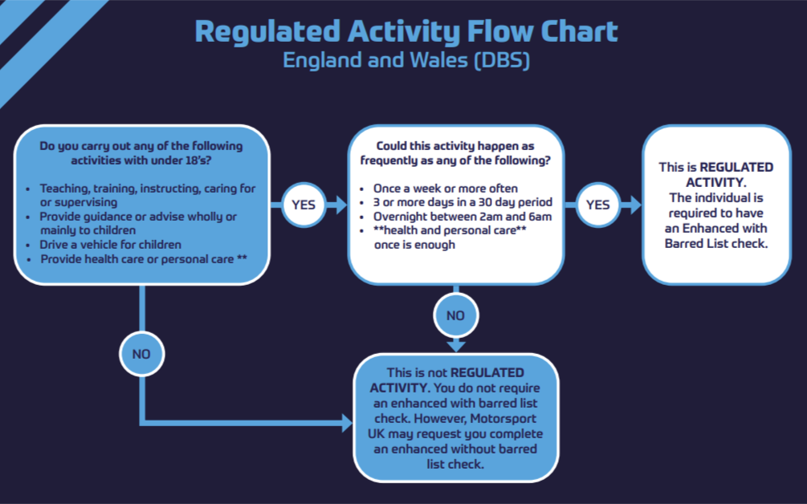

Scotland

In Karting, the below roles currently require a Suitability Check due to their participation in Regulated Activity:
  - Club Safeguarding Officer
  - Clerk of the Course
  - Steward
  - Scrutineer
  - Team Manager
  - Mechanic / Driver Coach
If you believe members of your Club are working in Regulated Activity, please contact vetting@motorsportuk.org to request a Suitability Check.
The process includes:
- Online application form
- Document verification (Post Office or Digital)
- Police Check
- Certificate is issued directly to the applicant

Safeguarding Induction
When new staff or volunteers join your Club, it is important that they receive a Safeguarding Induction. This ensures that everyone knows the policies and procedures your Club has regarding Safeguarding, and that they understand their responsibilities.
This induction may include:
- Signposting to E-Learning modules (Motorsport UK)
- Explanation of policies and procedures for Safeguarding
- Highlighting who your CSO is
- Providing information on how to report concerns

