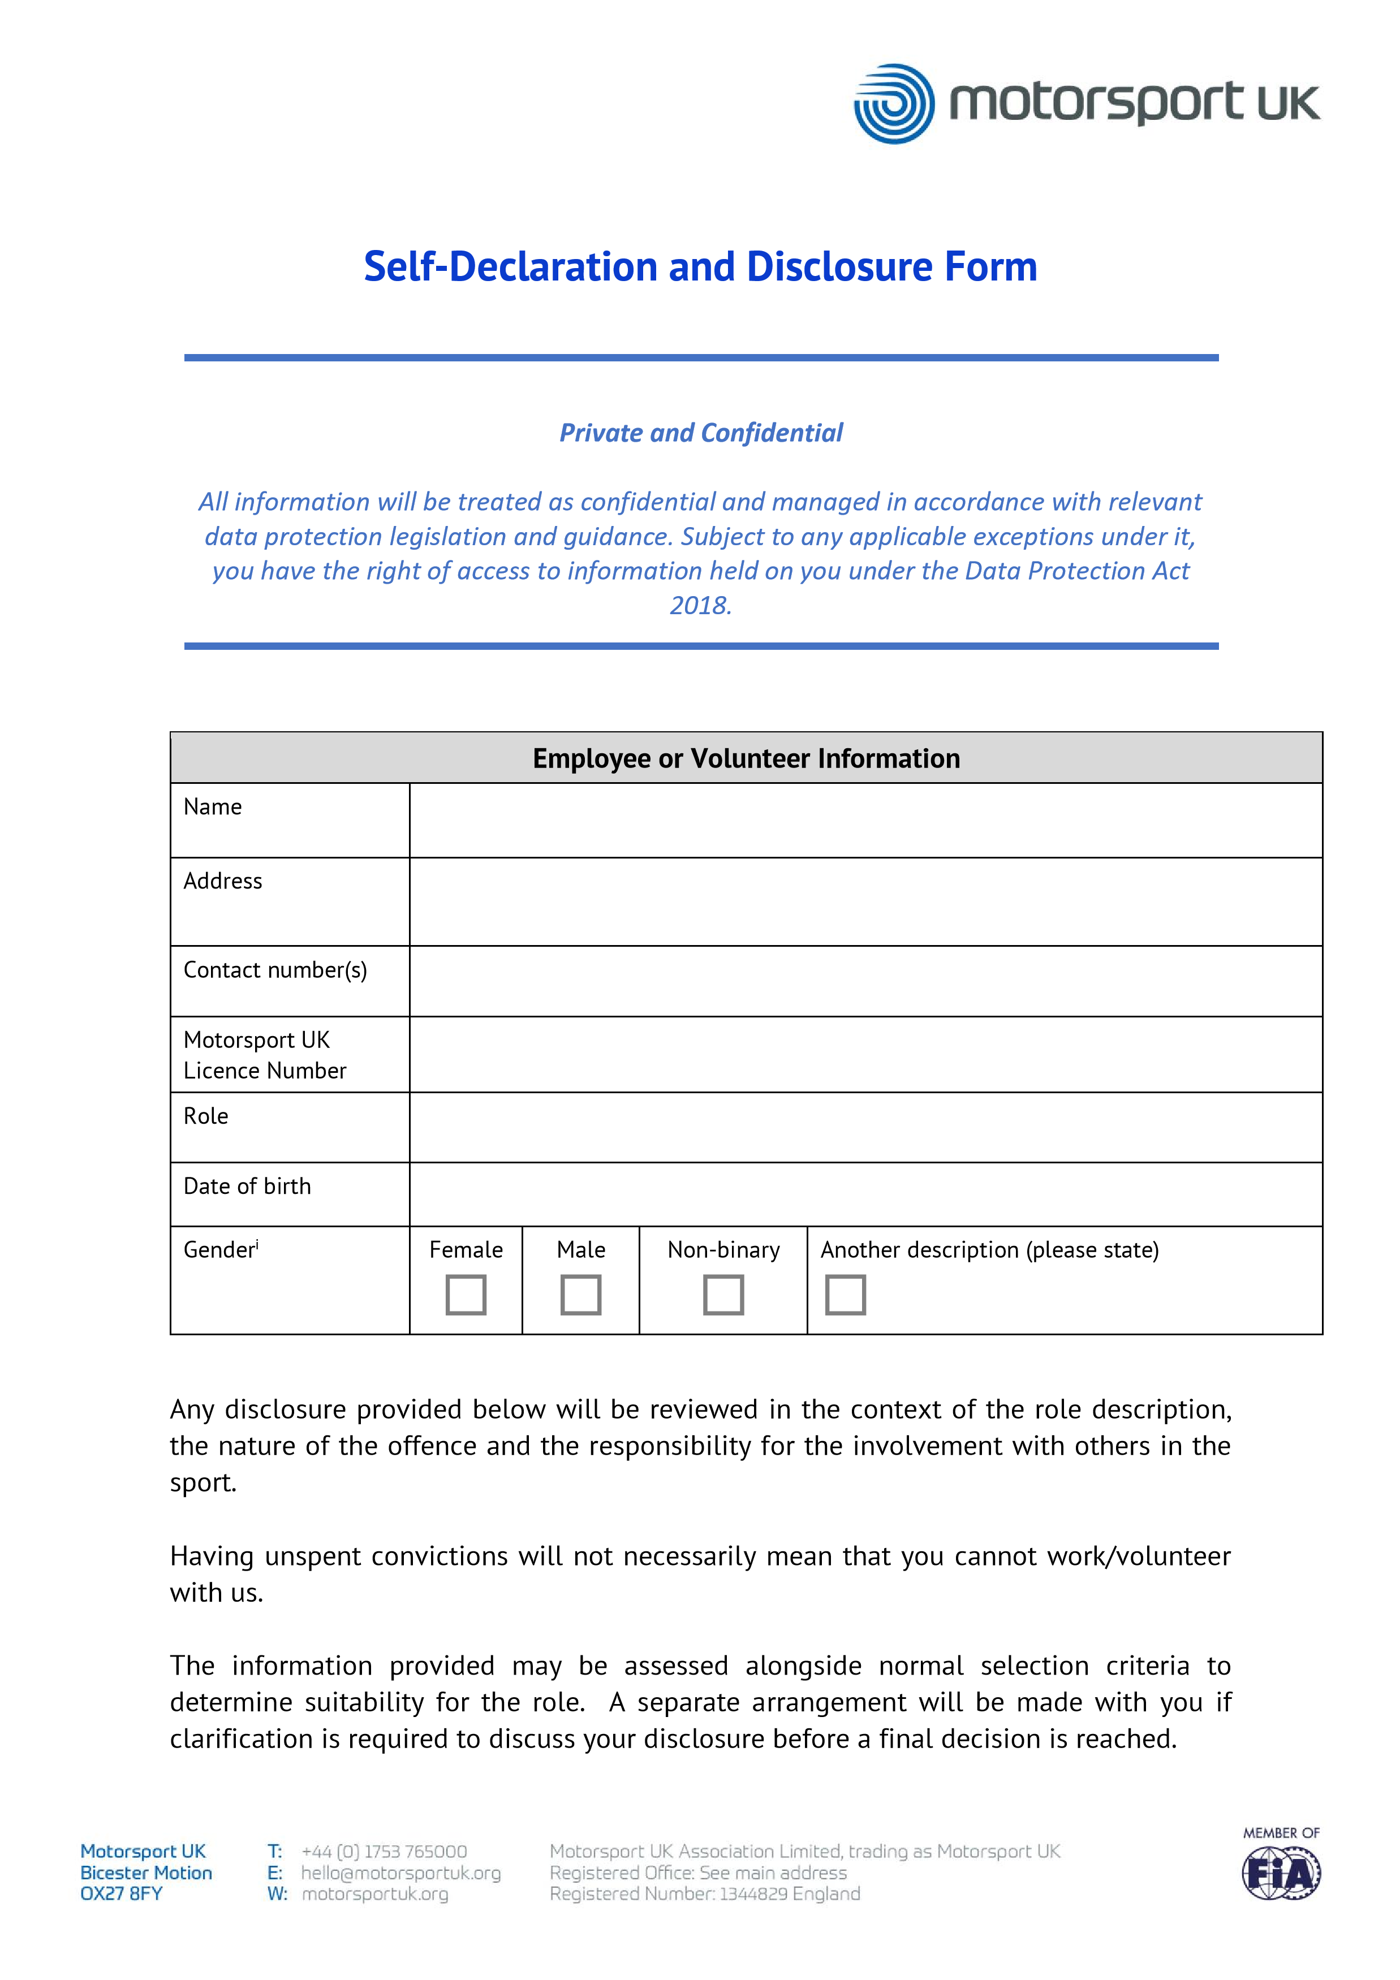
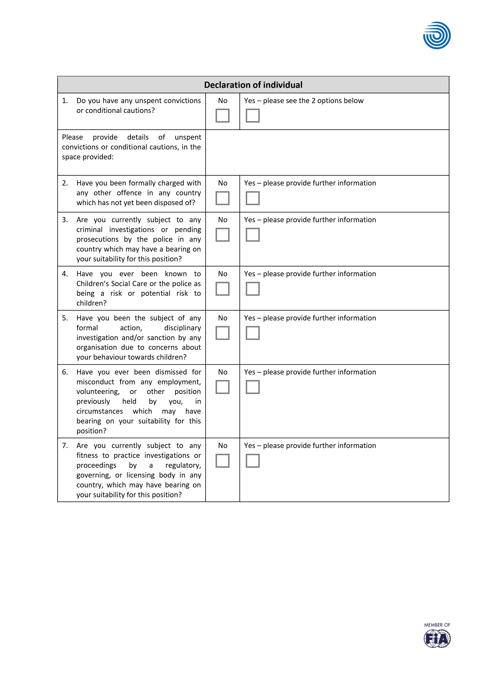


Confirmation of declaration

Please tick the boxes below and then sign this form.

◻

I agree that the information provided here may be processed in connection with

recruitment purposes and I
understand that an offer of
a
role may be withdrawn, or dismissal may result if information is not disclosed
by me and subsequently comes to

the employer’s

attention.

◻

In accordance with the Motorsport UK procedures,
)
(
if required to do so

I agree to provide a valid
Suitability

Check
¹

and consent to Motorsport UK clarifying any information provided on the disclosure with the
agencies providing it.

◻

I agree to inform
my employer

within 24 hours if I am subsequently investigated by any agency or
organisation in relation to concerns about my behaviour towards children or young people.

I declare that the information provided on this form is
correct. I understand that the
declaration of a criminal record will not necessarily prevent me from being offered this
role
.

Signature

✗

Print name

Today’s date

1

DBS, PVG or Access NI depending

on the country you work in.

